**LAB 10**

**T - Test**

**Aim: To conduct T-test**

**New-Term:**

1. **t.test(): This function is used to perform a t-test in R. It compares the means of two groups and determines if they are significantly different from each other. In the code, it is used to perform an independent t-test (t.test(x1, x2)) and a paired t-test (t.test(t1, t2, paired = TRUE)).**
2. **qt(): This function is used to calculate the quantile function (inverse cumulative distribution function) of a t-distribution. It calculates the value corresponding to a given probability or percentile. In the code, it is used to calculate the critical value (tv) for the independent t-test.**
3. **qf(): This function is used to calculate the quantile function (inverse cumulative distribution function) of an F-distribution. It calculates the value corresponding to a given probability or percentile. In the code, it is used to calculate the critical value (tv) for the variance test.**
4. **var.test(): This function is used to perform a variance test in R. It compares the variances of two groups and determines if they are significantly different from each other. In the code, it is used to perform a variance test (var.test(s1, s2)).**

**Input:**

**# This code performs a t-test and a variance test on two sets of data.**

**# First, we define the two sets of data.**

**x1 = c(19, 17, 15, 21, 16, 18, 16, 14)**

**x2 = c(15, 14, 15, 19, 15, 18, 16, 20)**

**# Next, we calculate the mean, variance, and t-statistic for each set of data.**

**mean(x1)**

**mean(x2)**

**var(x1)**

**var(x2)**

**t = t.test(x1, x2)**

**# We can then use the t-statistic to calculate the critical value.**

**cv = t$statistic**

**tv = qt(0.975, 14)**

**# If the t-statistic is less than or equal to the critical value, we can reject the null hypothesis.**

**if (cv <= tv) {**

**print("Accept H0")**

**} else {**

**print("H1 Accept")**

**}**

**# The code then performs a paired t-test on the two sets of data.**

**# This is a t-test that is used when the two sets of data are related.**

**t1 = c(19, 17, 15, 21, 16, 18, 16, 14, 19, 20)**

**t2 = c(15, 14, 15, 19, 15, 18, 16, 20, 22, 19)**

**t = t.test(t1, t2, paired = TRUE)**

**# We can then calculate the p-value for the paired t-test.**

**alpha = 0.05**

**tv = t$p.value**

**# If the p-value is greater than the alpha level, we can accept the null hypothesis.**

**if (tv > alpha) {**

**print("Accept H0")**

**} else {**

**print("H1 Accepted")**

**}**

**# Finally, the code performs a variance test on the two sets of data.**

**# This is a test that is used to determine if the variances of the two sets of data are equal.**

**s1 = c(19, 17, 15, 21, 16, 18, 16, 14)**

**s2 = c(15, 14, 15, 19, 15, 18, 16, 20)**

**f = var.test(s1, s2)**

**# We can then calculate the critical value for the variance test.**

**cv = f$statistic**

**tv = qf(0.95, 7, 7)**

**# If the t-statistic is less than or equal to the critical value, we can reject the null hypothesis.**

**if (cv <= tv) {**

**print("Accept H0")**

**} else {**

**print("H1 Accpeted")**

**}**

OUTPUT:

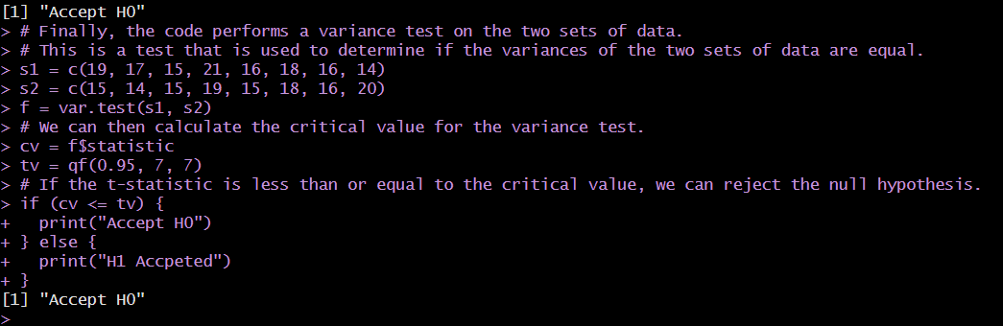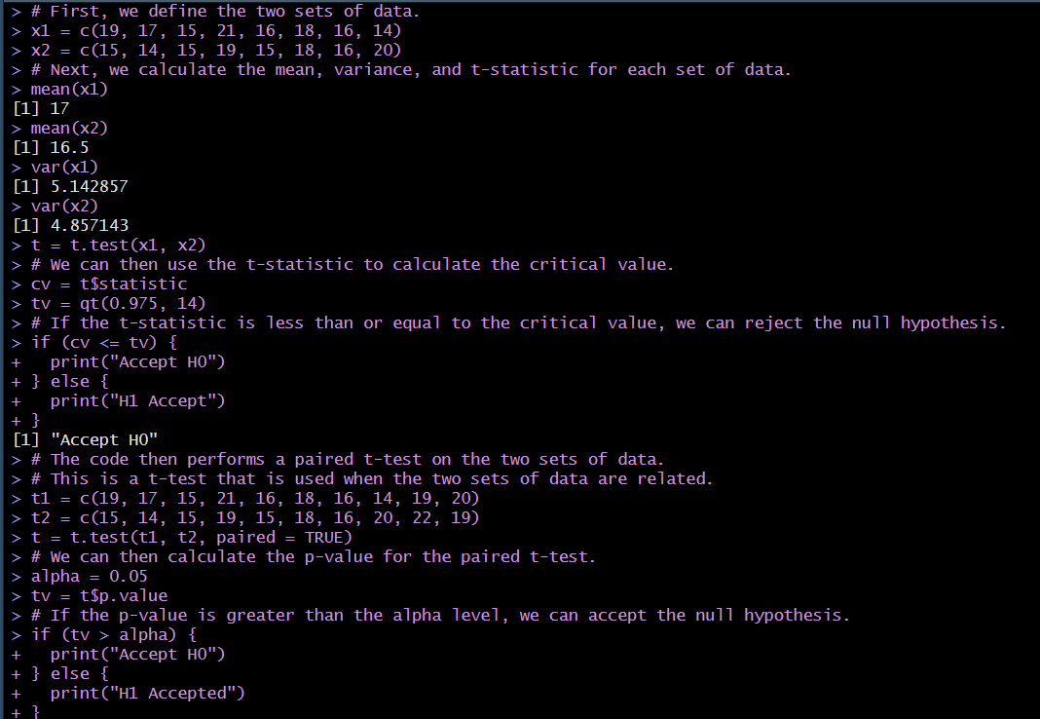

**Inference:**

**If the cv>tv then t test H0 hypothesis is accepted or else it H0 is not accepted.**

**\*\*\*\*\*\*\*\*\*\*\*\*\*\*\*\*\*\*\*\*\*\*\*\*\*\***